SUPERMARKET SALES ANALYSIS
Data Analysis Using R Programming

VIRTUAL R DATA ANALYST INTERN
WEEK – 01
Data Cleaning & Preliminary Analysis with R
Submitted by: RAJESH M

TABLE OF CONTENTS
- Introduction
- Background of the Study
- Problem Statement
- Objectives of the Study
- Scope of the Study
- Dataset Description
- Tools and Technologies
- Data Importing
- Data Inspection
- Data Cleaning
- Data Transformation
- Exploratory Data Analysis
- Descriptive Statistics
- Sales Distribution
- Quantity and Sales Analysis
- Unit Price and Sales Analysis
- Branch-wise Analysis
- City-wise Analysis
- Customer Type Analysis
- Gender Analysis
- Product Line Analysis
- Payment Method Analysis
- Transaction Analysis
- Combined Analysis
- Boxplot Analysis
- Key Findings
- Business Insights
- Recommendations
- Limitations
- Future Scope
- Conclusion
- References
- Appendix – R Code
- Overall Project Summary

INTRODUCTION
Data analysis is an important process used by organizations to understand information and support decision-making.
Supermarkets generate large amounts of data every day through customer transactions. This data contains valuable information about products, customers, sales, payment methods, and locations.
Analyzing this information can help businesses identify their best-performing products, understand customer purchasing behavior, compare branches, and improve sales performance.
In this project, R programming is used to analyze supermarket sales data. R provides several useful functions for data manipulation, statistical analysis, and visualization.
The project uses different graphical techniques to convert raw data into meaningful information.

BACKGROUND OF THE STUDY
The retail and supermarket industry generates a large volume of transaction data. Each transaction can provide information about customer behavior and business performance.
Traditional manual analysis of large datasets can be time-consuming and may make it difficult to identify patterns.
Data analytics provides a systematic way to examine large amounts of information.
In this project, supermarket sales data is analyzed using R. The analysis focuses on important variables such as sales, quantity, unit price, branch, city, customer type, gender, product line, and payment method. The results can help identify which categories and locations contribute more to sales and which areas may require improvement.

PROBLEM STATEMENT
Supermarkets need to understand their sales performance in order to make effective business decisions.

- Without proper analysis, it may be difficult to identify:
- Which branch performs better.
- Which city has higher sales.
- Which product line has stronger demand.
- Which customer type contributes more sales.
- How gender affects purchasing behavior.
- Which payment methods are frequently used.
- Whether quantity is related to sales.
- Whether unit price affects sales.
- How sales values are distributed.
Therefore, this project uses R programming to analyze the supermarket dataset and generate meaningful insights from the available information.

OBJECTIVES OF THE STUDY
The major objectives of the project are:
- To understand the structure of supermarket sales data.
- To clean and prepare the dataset for analysis.
- To perform exploratory data analysis using R.
- To compare sales across different branches.
- To compare sales across different cities.
- To analyze sales by customer type.
- To analyze sales by gender.
- To identify the performance of different product lines.
- To analyze different payment methods.
- To study the relationship between quantity and sales.
- To study the relationship between unit price and sales.
- To identify unusual or high-value sales observations.
- To generate meaningful business insights

SCOPE OF THE STUDY
The scope of this project is limited to the analysis of the given supermarket sales dataset.
- Sales performance.
- Customer purchasing behavior.
- Product categories.
- Branch performance.
- City performance.
- Gender-wise transactions.
- Customer type.
- Payment methods.
- Quantity sold.
- Unit price.
- Sales distribution

DATASET DESCRIPTION
The supermarket dataset contains transaction-level information related to customer purchases.
Important variables used in the analysis include:
- Branch – identifies the supermarket branch.
- City – identifies the city where the branch is located.
- Customer Type – identifies whether the customer is a member or Normal customer.
- Gender – identifies customer gender.
- Product Line – represents the category of products purchased.
- Unit Price – represents the price of one unit of the product.
- Quantity – represents the number of units purchased.

TOOLS AND TECHNOLOGIES
R Programming
R is the main programming language used for this project. It is widely used for statistical analysis, data visualization, and data science.
RStudio
RStudio is the development environment used to write and execute R code.
CSV Dataset
The supermarket sales data is stored in CSV format. CSV files are commonly used to store structured tabular data.
Visualization
Graphs such as bar charts, histograms, scatter plots, and boxplots are used to visualize the results.

DATA IMPORTING
The first step in the analysis is importing the supermarket dataset into R. The CSV file is loaded into R using the appropriate data import function. After importing the dataset, the data is stored in a data frame. A data frame allows rows and columns to be accessed and analyzed easily. The imported data is then checked to ensure that the dataset has been loaded correctly.
Purpose of Data Importing
- To bring the dataset into R.
- To access the variables.
- To perform data cleaning.
- To perform statistical analysis.
- To create visualizations.
DATA INSPECTION
After importing the dataset, the next step is to inspect its structure.
Data inspection helps identify:
- Number of observations.
- Number of variables.
- Variable names.
- Data types.
- Missing values.
- Duplicate records.
- Incorrect values.
Functions such as head (), str (), summary (), and dim () can be used for initial inspection.
This step is important because understanding the structure of the dataset helps in selecting suitable analysis methods.

DATA CLEANING
Data cleaning is an important step before performing analysis. The dataset was checked for missing values, incorrect data types, duplicate records, and inconsistent values. Missing values can affect statistical calculations and graphs. Therefore, the dataset should be checked carefully before analysis The relevant columns were also converted into suitable formats wherever necessary. Data cleaning improves the quality and reliability of the analysis.
Main Data Cleaning Activities
- Checking missing values.
- Checking duplicate records.
- Checking data types.
- Checking unusual values.
- Removing unnecessary columns where applicable.
- Preparing variables for analysis.
# Missing values
colSums(is.na(sales_data))
# Duplicate records
sum(duplicated(sales_data))
# Dataset structure
str(sales_data)
# Dataset dimensions
dim(sales_data)
# Summary
summary(sales_data)

DATA TRANSFORMATION
Data transformation involves converting the dataset into a format suitable for analysis. In this project, categorical variables such as Branch, City, Customer Type, Gender, Product Line, and Payment were used for grouping and comparison.
Sales-related numerical variables such as Quantity, Unit Price, and Sales were used for statistical calculations and graphical analysis.
Grouped averages and transaction counts were calculated to compare different categories. Data transformation makes it easier to identify relationships and patterns within the dataset.

EXPLORATORY DATA ANALYSIS
Exploratory Data Analysis (EDA) is the process of examining a dataset to understand its major characteristics. EDA was performed using numerical summaries and graphical methods.
The following analyses were performed:
- Sales distribution.
- Quantity vs Sales.
- Unit Price vs Sales.
- Average Sales by Branch.
- Average Sales by City.
- Average Sales by Customer Type.
- Average Sales by Gender.
- Average Sales by Product Line.
- Average Sales by Payment Method.
- Transaction analysis.
DESCRIPTIVE STATISTICS
Descriptive statistics provide a summary of the main characteristics of numerical data.
Important measures include:
- Mean.
- Median.
- Minimum.
- Maximum.
- Standard deviation.
- Quartiles.
The average sales value provides an overall indication of typical transaction performance. The minimum and maximum values show the range of sales. The boxplot further helps understand the median, quartiles, spread, and potential outliers. Descriptive statistics provide a foundation for understanding the sales dataset before detailed comparisons are performed.
SALES DISTRIBUTION
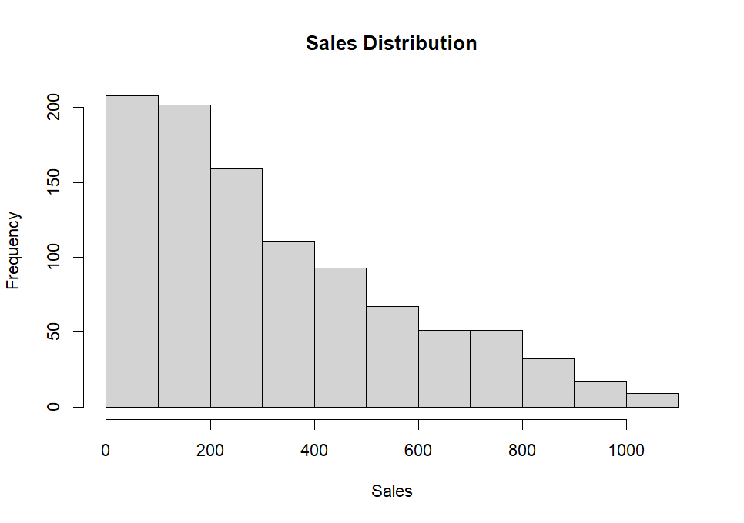
The Sales Distribution histogram shows how transaction sales values are distributed. Most transactions are concentrated in the lower and medium sales ranges. The frequency decreases as the sales value increases.
The distribution has a longer tail toward higher sales values, indicating a positive/right skew.
This means that high-value transactions occur less frequently than low and medium-value transactions.
The graph provides an overall understanding of the sales pattern in the dataset.
QUANTITY VS SALES
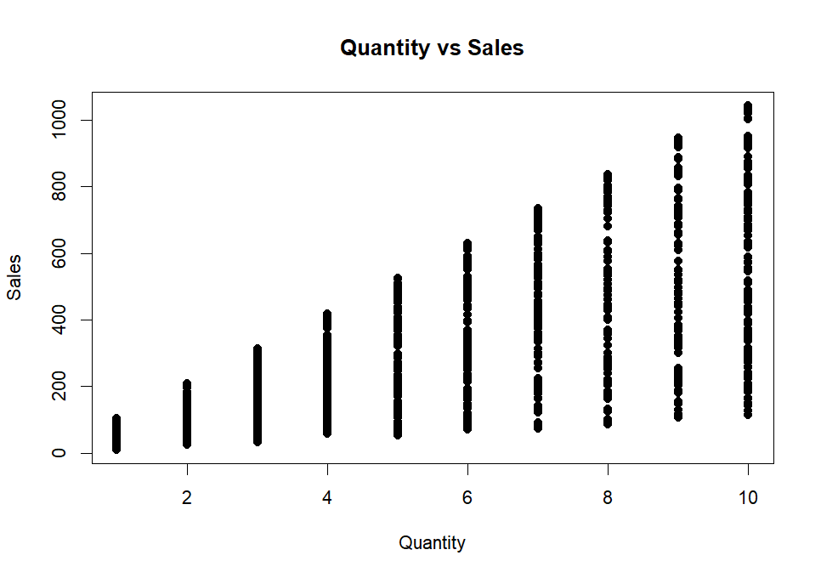
The Quantity vs Sales scatter plot shows a clear positive relationship between quantity and sales. As the quantity purchased increases, sales generally increase.
Transactions involving higher quantities show a wider range of sales values. This indicates that quantity is an important factor affecting total sales.
The relationship can be useful for understanding how increasing the number of units sold can contribute to revenue growth.

UNIT PRICE VS SALES
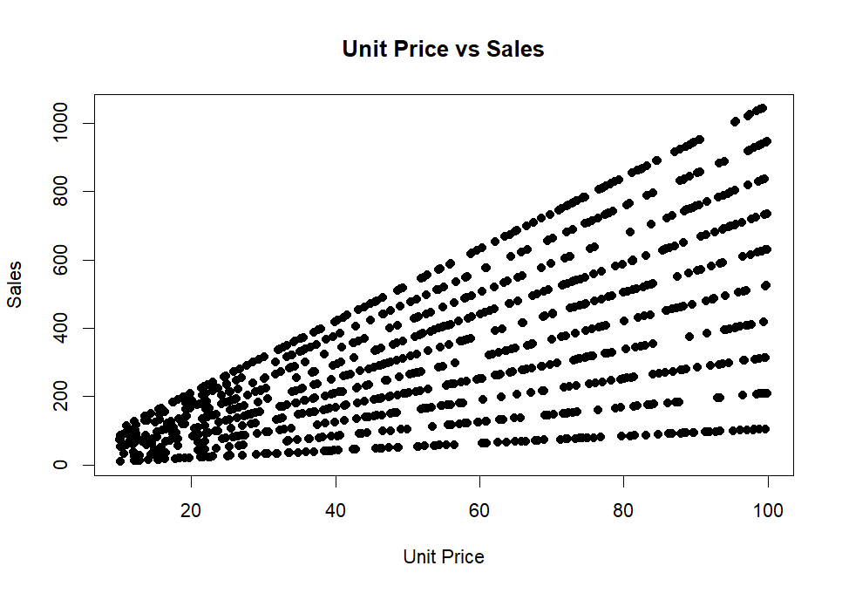
The Unit Price vs Sales scatter plot shows a positive relationship between unit price and total sales. Higher unit prices are generally associated with higher sales values. However, total sales are influenced by both unit price and quantity purchased. Therefore, the graph indicates that sales value depends on the combined effect of product price and sales volume. This analysis helps the business understand how pricing and quantity contribute to overall sales performance.
Graph: Scatter Plot
- X-axis: Unit Price
- Y-axis: Sales
AVERAGE SALES BY BRANCH
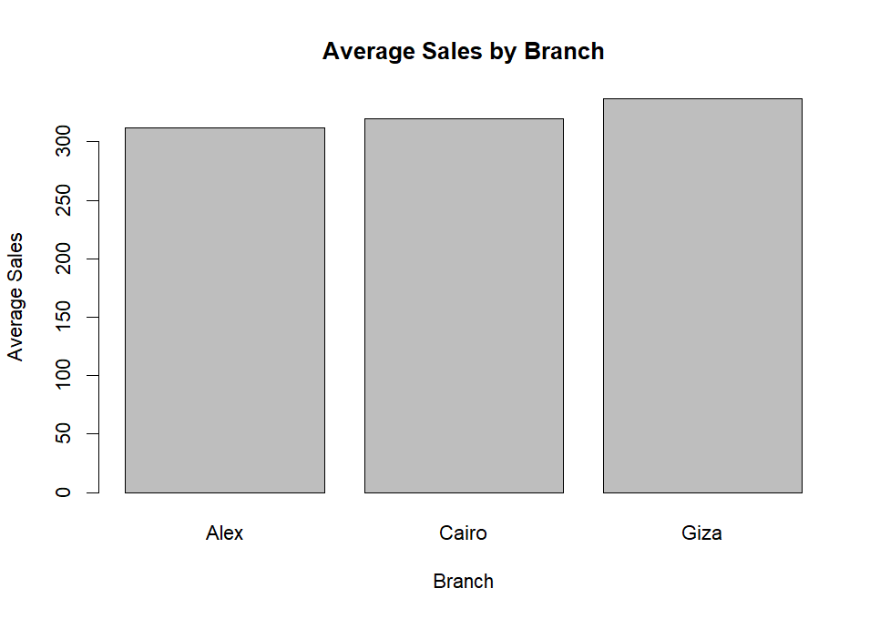
The branch-wise analysis compares the average sales of Alex, Cairo, and Giza branches.
The graph shows that Giza has the highest average sales, followed by Cairo, while Alex has the lowest average sales. The differences suggest that branch-level performance is not identical.
Management can investigate factors such as customer demand, product availability, promotions, and location to understand the differences.
AVERAGE SALES BY CITY
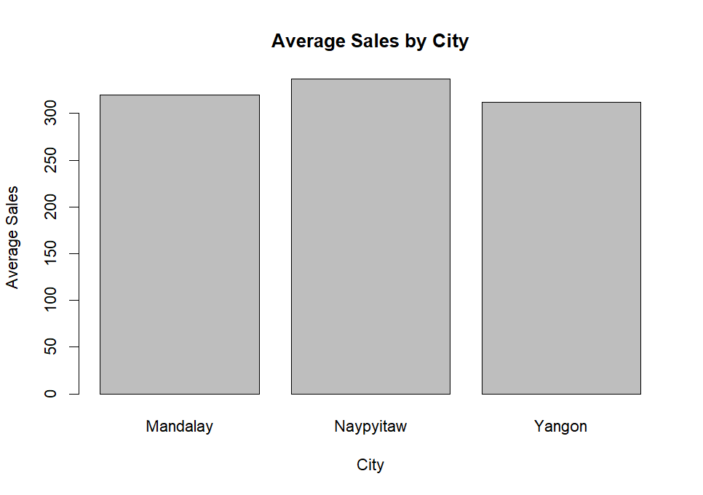
The analysis compares sales performance across Mandalay, Naypyitaw, and Yangon.
Naypyitaw shows the highest average sales, while Mandalay follows and Yangon has the lowest average sales among the three cities.
This information can help management compare geographical performance. The business can study the reasons behind differences in city-level sales and develop location-specific strategies

AVERAGE SALES BY CUSTOMER TYPE
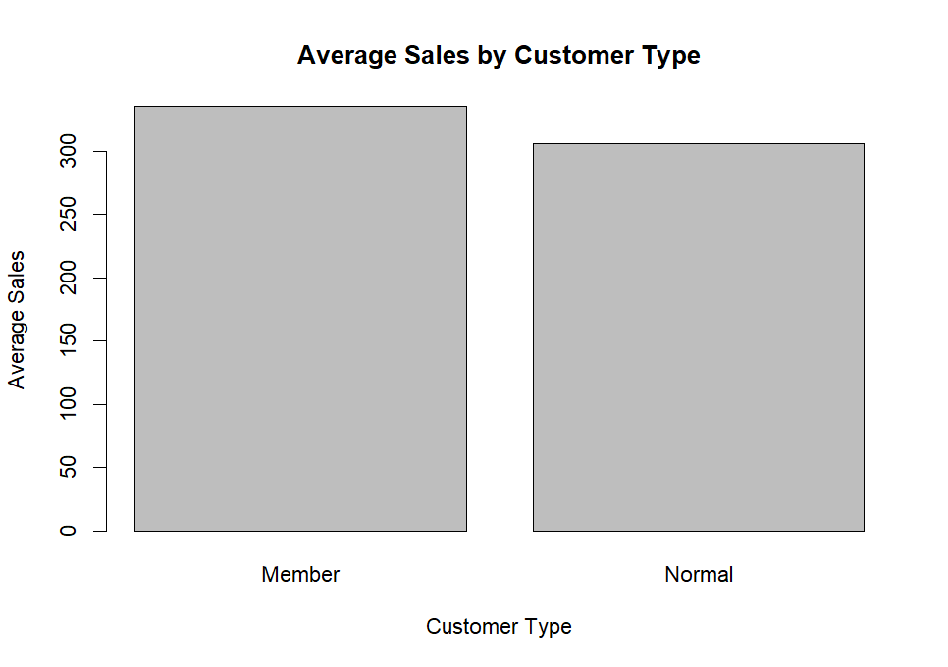
The analysis compares Member and Normal customers. Member customers show a higher average sales value than Normal customers.
This suggests that membership customers may contribute more value per transaction.
The supermarket can use loyalty programs, member-exclusive offers, reward points, and personalized promotions to encourage customer retention.

AVERAGE SALES BY GENDER
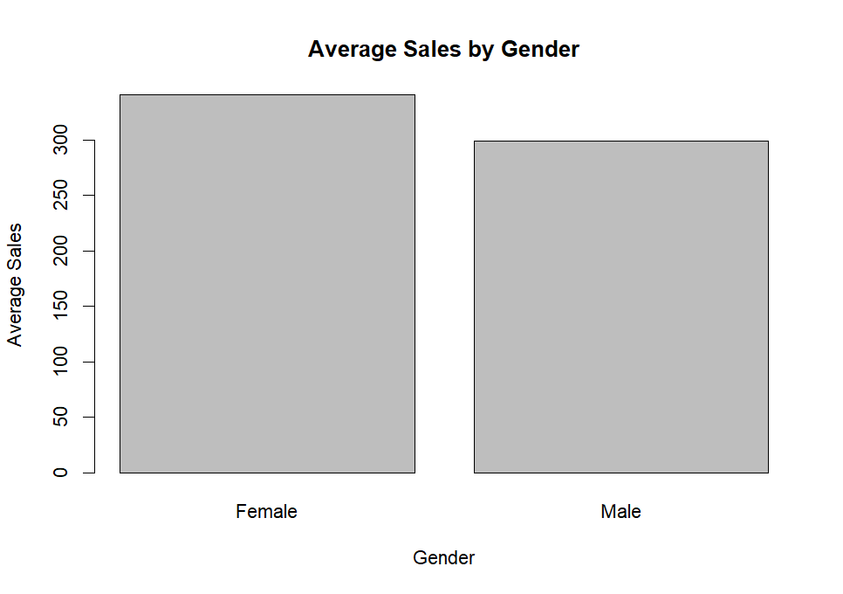
- The analysis compares the average sales of Female and Male customers.
- Female customers show a higher average sales value compared with Male customers.
This indicates differences in purchasing behavior between the two groups. Businesses can use this information to understand customer preferences and design suitable marketing strategies.

TRANSACTIONS BY GENDER
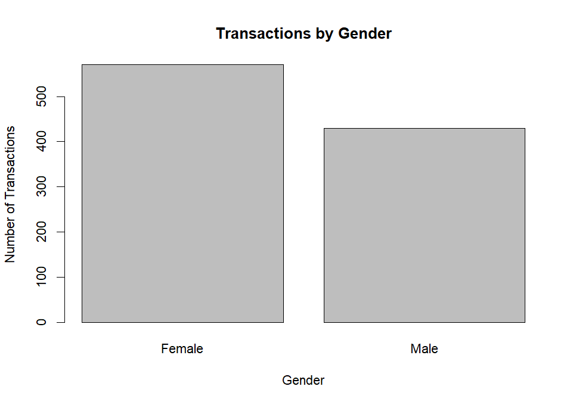
The transaction analysis shows that Female customers account for more transactions than Male customers. The higher number of female transactions indicates that female customers represent a larger share of the transaction records.
This information can help the supermarket understand customer composition and plan suitable promotional activities. Transaction frequency and average sales should be considered together because a higher number of transactions does not always mean higher average transaction value.
AVERAGE SALES BY PRODUCT LINE
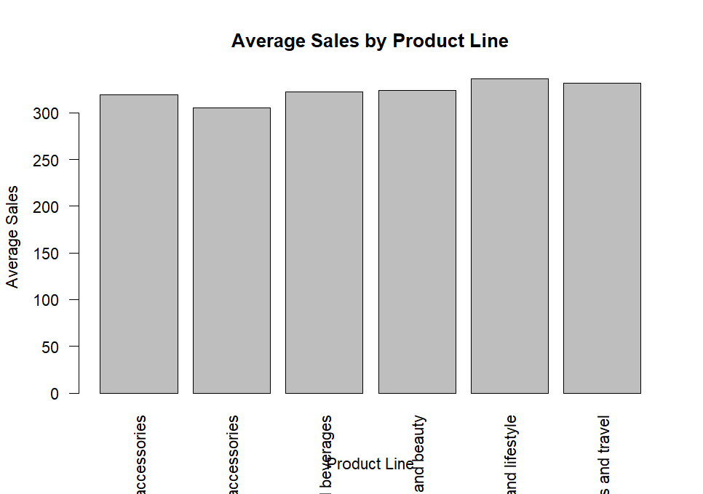

The analysis compares average sales across six product lines.
- Home and Lifestyle has one of the highest average sales values, while Fashion Accessories has a comparatively lower average sales value.
- Sports and Travel and other product categories also show strong sales performance.
- The supermarket can focus on high-performing product categories while investigating ways to improve lower-performing categories.
TRANSACTIONS BY PRODUCT LINE

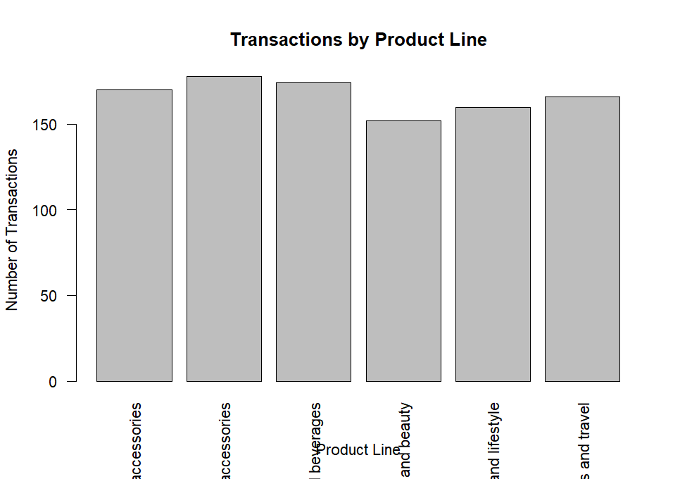

The transaction analysis shows differences in the number of transactions across product lines.
- Food and Beverages has the highest transaction frequency among the product categories. Health and Beauty has comparatively fewer transactions.
- Transaction frequency can help management understand product demand and make better inventory decisions. High transaction frequency categories may require sufficient stock availability to avoid shortages.
Average Sales by Payment Method

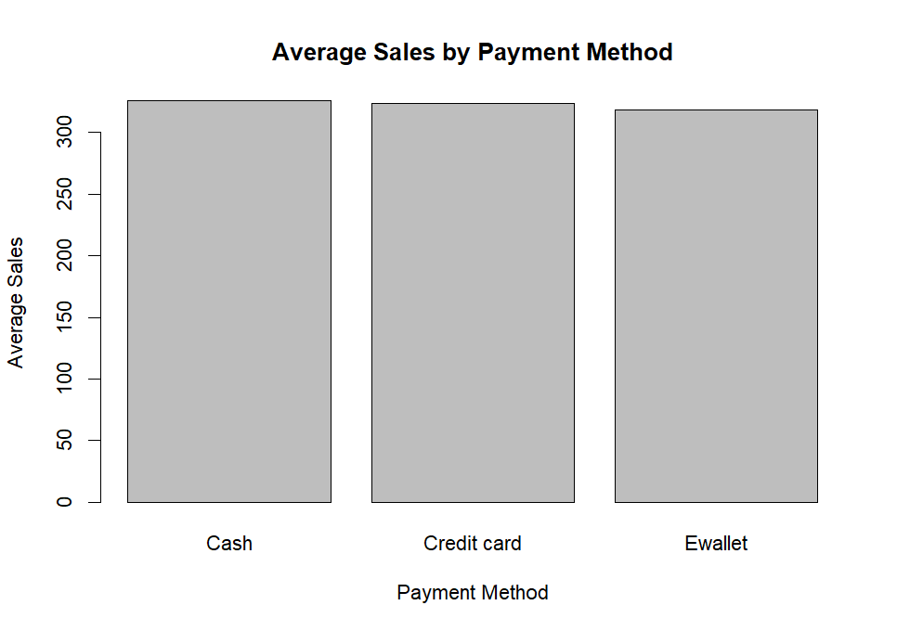

- The average sales values across Cash, Credit Card, and E-wallet are relatively close.
- Cash shows a slightly higher average sales value, followed by Credit Card and E-wallet.

Transactions by Payment Method

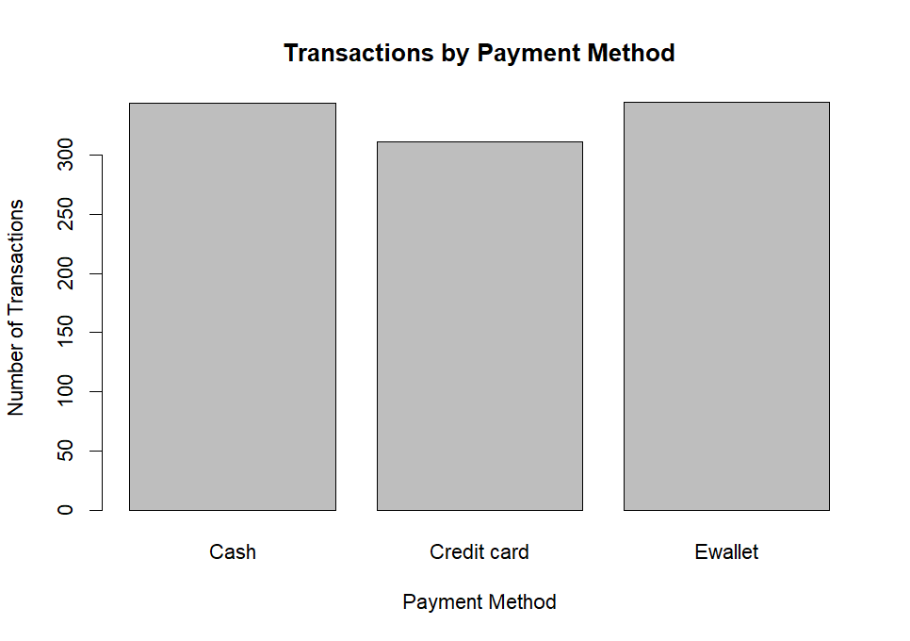
- Cash and E-wallet have relatively higher transaction counts, while Credit Card has a comparatively lower number of transactions.
- This indicates that customers use different payment methods and that payment preference may influence transaction frequency.

SALES BOXPLOT
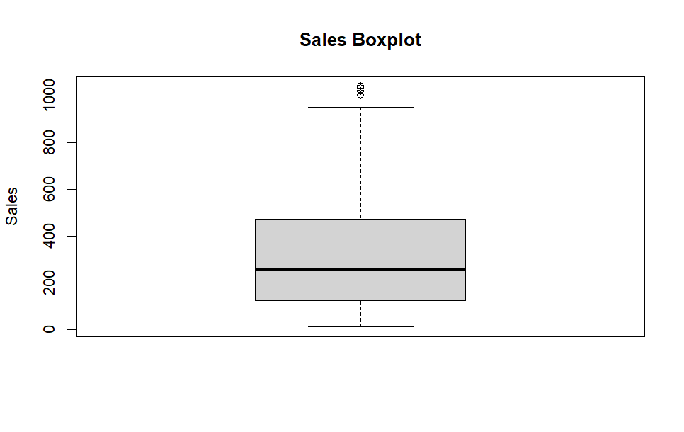
The Sales Boxplot provides information about the distribution of sales values.
The box represents the middle portion of the observations, while the line inside the box represents the median.
The whiskers represent the typical range of the data, while observations beyond the whiskers may represent potential outliers.
Several high-value observations can be seen above the upper whisker. These observations represent transactions with unusually high sales values compared with most transactions.
COMBINED ANALYSIS AND BUSINESS INSIGHTS
- COMBINED ANALYSIS
- The combined analysis provides deeper insights into supermarket performance.
- The analysis of gender and product line shows that purchasing patterns differ between Female and Male customers.
- The city and product-line analysis indicates that product performance can vary by location.
- Quantity vs Sales shows that higher quantity generally results in higher sales.
- Unit Price vs Sales also shows a positive relationship between unit price and total sales.
- These findings demonstrate that sales performance depends on multiple factors rather than a single variable.
- BUSINESS INSIGHTS
- Giza has strong branch-level performance.
- Naypyitaw has the highest city-level average sales.
- Member customers show higher average sales.
- Female customers have higher average sales.
- Food and Beverages has high transaction frequency.
- Quantity has a positive relationship with sales.
- Unit Price has a positive relationship with sales.
- High-value sales transactions occur less frequently.

RECOMMENDATIONS
Based on the analysis, the following recommendations are suggested:
- Improve the performance of lower-performing branches.
- Study the successful strategies of high-performing branches.
- Strengthen membership and loyalty programs.
- Maintain sufficient inventory for high-demand products.
- Use customer preferences for targeted promotions.
- Develop city-specific marketing strategies.
- Encourage higher-value purchases through suitable product bundles.
- Monitor high-value transactions separately.
- Promote suitable digital payment options.

LIMITATIONS
The study has some limitations.
The analysis is based only on the available dataset. The dataset may not contain information about customer income, age, profit margin, operating costs, promotional campaigns, or seasonal factors.
Therefore, the results mainly describe the patterns present in the available transaction data.
FUTURE SCOPE
Future studies can include:
- Sales forecasting.
- Customer segmentation.
- Profit analysis.
- Predictive modelling.
- Machine learning.
- Customer lifetime value analysis.
- Time-series analysis.
- Advanced dashboards using Power BI or Tableau.
- Product recommendation systems.
REFERENCES
- R Programming Documentation.
- RStudio Documentation.
- Basic Statistical Analysis and Data Visualization References.
- Supermarket Sales Dataset used for academic analysis.
- Academic materials related to Data Analytics and Exploratory Data Analysis.

CONCLUSION
The project “Supermarket Sales Data Analysis Using R” successfully demonstrates the use of R programming for data cleaning, transformation, exploratory analysis, and visualization.
The analysis identified important patterns in supermarket sales. Branches, cities, customer types, gender, product lines, payment methods, quantity, and unit price were analyzed.
The results show that sales performance varies across different business categories. Giza shows strong branch-level performance, while Naypyitaw has the highest average sales among the cities.
Member customers show higher average sales, while Female customers have higher average sales and transaction frequency in the analyzed dataset.
The Quantity vs Sales and Unit Price vs Sales graphs indicate positive relationships with total sales.
Overall, the project demonstrates how data analysis can convert raw transaction records into useful business insights. The findings can support better decisions related to marketing, inventory management, customer retention, product promotion, and sales planning.

APPENDIX – R CODE
The following R programming concepts were used during the project:
- Data import.
- Data inspection.
- Missing-value checking.
- Data cleaning.
- Data transformation.
- Group-wise average calculation.
- Bar charts.
- Histograms.
- Scatter plots.
- Boxplots.
The complete R script used for the analysis can be attached as an appendix to this report.

SUPERMARKET SALES ANALYSIS USING R
# APPENDIX – R CODE
# 1. Import Dataset
sales_data <- read.csv("SuperMarket Analysis.csv")

# 2. View Dataset
head(sales_data)
tail(sales_data)

# 3. Dataset Structure
str(sales_data)
dim(sales_data)
summary(sales_data)

# 4. Check Missing Values
colSums(is.na(sales_data))

# 5. Check Duplicate Records
sum(duplicated(sales_data))

# 6. Check Column Names
names(sales_data)

# 7. Data Cleaning
sales_data$Branch <- as.factor(sales_data$Branch)
sales_data$City <- as.factor(sales_data$City)
sales_data$Gender <- as.factor(sales_data$Gender)
sales_data$`Customer type` <- as.factor(sales_data$`Customer type`)
sales_data$`Product line` <- as.factor(sales_data$`Product line`)
sales_data$Payment <- as.factor(sales_data$Payment)

# 8. Descriptive Statistics
mean(sales_data$Sales)
median(sales_data$Sales)
min(sales_data$Sales)
max(sales_data$Sales)
sd(sales_data$Sales)

# 9. Sales Distribution
hist(sales_data$Sales,
main = "Sales Distribution",
xlab = "Sales",
ylab = "Frequency")

# 10. Quantity vs Sales
plot(sales_data$Quantity, sales_data$Sales,
main = "Quantity vs Sales",
xlab = "Quantity",
ylab = "Sales")

# 11. Unit Price vs Sales
plot(sales_data$`Unit price`, sales_data$Sales,
main = "Unit Price vs Sales",
xlab = "Unit Price",
ylab = "Sales")

# 12. Average Sales by Branch
branch_sales <- aggregate(Sales ~ Branch,
data = sales_data,
FUN = mean)

barplot(branch_sales$Sales,
names.arg = branch_sales$Branch,
main = "Average Sales by Branch",
xlab = "Branch",
ylab = "Average Sales")

# 13. Average Sales by City
city_sales <- aggregate(Sales ~ City,
data = sales_data,
FUN = mean)

barplot(city_sales$Sales,
names.arg = city_sales$City,
main = "Average Sales by City",
xlab = "City",
ylab = "Average Sales")

# 14. Average Sales by Customer Type
customer_sales <- aggregate(Sales ~ `Customer type`,
data = sales_data,
FUN = mean)

barplot(customer_sales$Sales,
names.arg = customer_sales$`Customer type`,
main = "Average Sales by Customer Type",
xlab = "Customer Type",
ylab = "Average Sales")

# 15. Average Sales by Gender
gender_sales <- aggregate(Sales ~ Gender,
data = sales_data,
FUN = mean)

barplot(gender_sales$Sales,
names.arg = gender_sales$Gender,
main = "Average Sales by Gender",
xlab = "Gender",
ylab = "Average Sales")

# 16. Average Sales by Product Line
product_sales <- aggregate(Sales ~ `Product line`,
data = sales_data,
FUN = mean)

barplot(product_sales$Sales,
names.arg = product_sales$`Product line`,
las = 2,
main = "Average Sales by Product Line",
xlab = "Product Line",
ylab = "Average Sales")

# 17. Transactions by Product Line
product_transactions <- table(sales_data$`Product line`)

barplot(product_transactions,
las = 2,
main = "Transactions by Product Line",
xlab = "Product Line",
ylab = "Number of Transactions")

# 18. Average Sales by Payment Method
payment_sales <- aggregate(Sales ~ Payment,
data = sales_data,
FUN = mean)

barplot (payment_sales$Sales,
names.arg = payment_sales$Payment,
main = "Average Sales by Payment Method",
xlab = "Payment Method",
ylab = "Average Sales")

# 19. Transactions by Payment Method
payment_transactions <- table(sales_data$Payment)

barplot (payment_transactions,
main = "Transactions by Payment Method",
xlab = "Payment Method",
ylab = "Number of Transactions")

# 20. Transactions by Gender
gender_transactions <- table(sales_data$Gender)

barplot (gender_transactions,
main = "Transactions by Gender",
xlab = "Gender",
ylab = "Number of Transactions")

# 21. Sales Boxplot
boxplot(sales_data$Sales,
main = "Sales Boxplot",
ylab = "Sales")

# 22. Correlation Analysis
cor(sales_data$Quantity, sales_data$Sales)
cor(sales_data$`Unit price`, sales_data$Sales)

END OF R CODE

PROJECT SUMMARY
The project analyzed supermarket sales data using R programming and generated multiple visualizations to understand sales performance.
The analysis covered:
• Branch.
• City.
• Customer Type.
• Gender.
• Product Line.
• Payment Method.
• Quantity.
• Unit Price.
• Sales.
• Transaction frequency.
The project successfully converted raw data into meaningful analytical results and business recommendations.

FINAL STATEMENT
This project provided practical knowledge and hands-on experience in analyzing real-world supermarket sales data using R programming. It demonstrated the complete data analysis workflow, including importing, inspecting, cleaning, transforming, analyzing, and visualizing raw transaction data to generate meaningful insights.

The analysis focused on key business variables such as Branch, City, Customer Type, Gender, Product Line, Payment Method, Quantity, Unit Price, and Sales. A range of analytical techniques, including descriptive statistics, bar charts, histograms, scatter plots, and boxplots, were applied to explore patterns and relationships within the dataset.
The study revealed variations in sales performance across branches and cities. Giza demonstrated strong branch-level performance, while Naypyitaw recorded the highest average sales among the cities analyzed. Member customers exhibited higher average sales compared to Normal customers, and Female customers showed relatively higher average sales and transaction frequency within the dataset.
The analysis also explored the relationship between Quantity, Unit Price, and Sales. The results indicated that higher quantities generally lead to increased sales values, while unit price also shows a positive association with total sales. Additionally, the evaluation of product lines and payment methods provided further insights into customer purchasing behavior and transaction preferences.
The project highlighted the importance of proper data cleaning and preparation prior to analysis. Identifying and addressing missing values, duplicate records, incorrect data types, and anomalies significantly improves the accuracy, consistency, and reliability of analytical outcomes.
Overall, the project successfully converted raw supermarket transaction data into actionable business insights. These findings can support management in understanding customer behavior, comparing branch and city performance, improving inventory planning, enhancing customer loyalty programs, and developing more effective marketing strategies.
In conclusion, this project demonstrates that data analysis is a powerful approach for transforming raw supermarket transaction data into meaningful business intelligence. Effective analysis and visualization enable organizations to better understand performance, identify opportunities for improvement, and make more informed, data-driven decisions.

- END OF REPORT *

